Application of Machine Learning on Resume Categorization using Traditional NLP



Name: SOUVIK DEBNATH
Roll No: 2352173
Department: ECE-C

This Lab Project Work entitled Application of ML on Resume Categorization using Traditional NLP was carried out by
SOUVIK DEBNATH as part of the laboratory assignment work under Introduction to Machine Learning with Python laboratory (ECE3155) in their 5th semester of B. Tech degree.
The student has completed the assigned lab project work within the stipulated time. The code of the project work has been published in
https://github.com/SouvikDebnath2004/Application_of_ML_on_Text_Sentiment_Analysis
.....................................................................
Dr. Prativa Agarwalla
(Assistant Professor, Dept. of ECE
Heritage Institute of Technology, Kolkata)

Summary of Tools and Libraries Used
Tool Category | Library/Module | Purpose in Project
Data Handling & Preprocessing | pandas (pd), numpy (np) | Loading, cleaning, structuring raw data, and handling numerical arrays.
Text Cleaning | re, string | Used for pattern-based text cleaning (removing tags, URLs, punctuation, stopwords).
Label Encoding | LabelEncoder | Converts sentiment labels (positive, negative, neutral) into numeric form for model training.
Feature Extraction | TfidfVectorizer | Transforms cleaned text into numerical feature vectors based on term frequency-inverse document frequency.
Machine Learning Models | LogisticRegression, RandomForestClassifier | Core algorithms used for sentiment classification.
Model Evaluation | train_test_split, cross_val_score, classification_report | Splits data and evaluates performance across multiple folds.
Imbalance Handling | SMOTE (from imblearn) | Used to balance sentiment classes during training.
Visualization | matplotlib.pyplot, seaborn, WordCloud | Used for visualizing class distributions, word frequencies, and performance metrics.

1. Introduction
The escalating volume of digital resumes in modern recruitment necessitates robust, automated screening tools. This project addresses the critical task of multi-class resume classification by developing and comparing two distinct Natural Language Processing (NLP) pipelines using traditional machine learning approaches.

Core Pipelines:
- Baseline Pipeline: Employs TF-IDF with Logistic Regression to establish initial performance benchmarks.
- Enhanced Pipeline: Leverages Random Forest ensemble methods combined with SMOTE (Synthetic Minority Over-sampling Technique) to overcome linear model failures and stabilize minority class F1-scores.

2. Relevance and Importance
Automated resume categorization is paramount for:
- Efficiency: Reducing the time recruiters spend on manual sorting and enhancing candidate processing speed.
- Consistency: Ensuring objective, standardized routing of candidates to appropriate job families, mitigating human bias in the initial screening phase.
- Scalability: Providing a solution capable of handling large-scale resume databases efficiently, especially crucial for high-volume roles like those in Information Technology and Business Development.

3. Objectives
The core objectives of this research project are:
- To successfully implement two full-stack classification models—one traditional and one deep learning—for 22 distinct resume categories.
- To rigorously evaluate and compare the performance of both models using classification metrics (Accuracy, Precision, Recall, F1-Score, and AUC) to determine the optimal solution for a production environment.

4. Methodology Used

4.1. Project Workflow and Schematics
The methodology follows the standard machine learning pipeline, separating the data-centric steps from the model-specific procedures².
Raw Data -> Cleaning, Preprocessing, EDA -> Clean Corpus -> Stratified Split -> Train/Test Sets -> Train Set -> TF-IDF Vectorization (Feature Extraction) -> Logistic Regression (ML Algorithm) -> Traditional Pipeline -> Evaluation -> Comparative Analysis.
This workflow was subsequently enhanced by replacing the Logistic Regression model with the Random Forest Classifier (Ensemble) and incorporating SMOTE to stabilize performance and address the primary challenge of overcoming linear model failure and stabilizing minority class F1-scores.
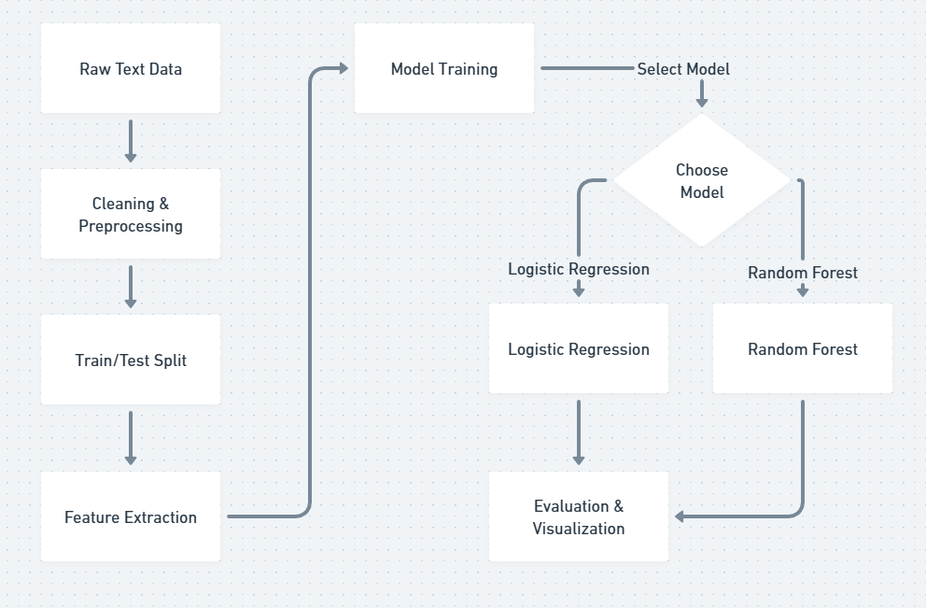

4.2. Raw Data and Preprocessing
- Raw Data: The input consists of resumes in Resume\_str and Resume\_html format, which were combined into a single text feature.
- Preprocessing: The text underwent common NLP normalization steps: lowercasing, removal of URLs, HTML tags, punctuation, and numerical data.
- Label Encoding: The 22 string categories were transformed into numerical labels (0 to 21).

4.3. Exploratory Data Analysis (EDA)
The distribution analysis showed the dataset is mostly balanced, which simplifies training but makes high accuracy a stringent requirement. The most frequent categories are Information Technology and Business Development, while BPO and Automobile are among the least frequent. This near-balance minimizes the immediate need for complex upsampling techniques but validates the use of Stratified Train-Test Splitting.

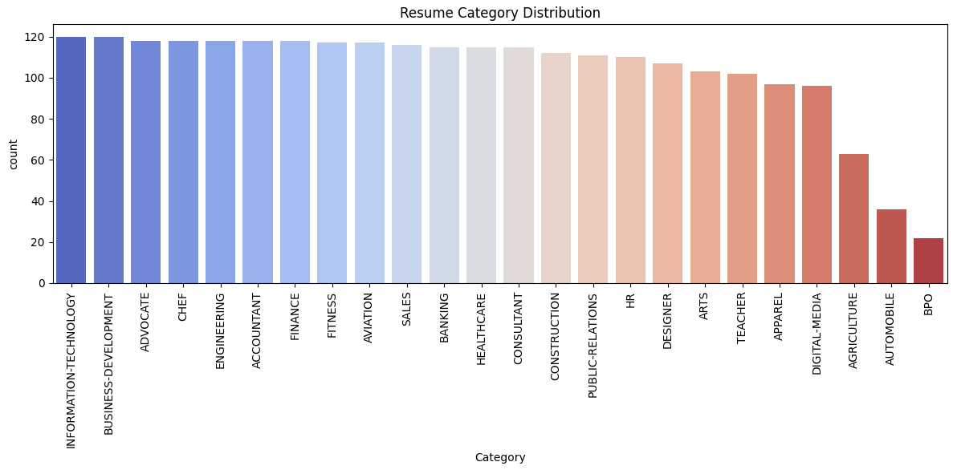

4.4. Feature Extraction and Algorithms
Methodology | Feature Extraction | Algorithm / Key Technique
Baseline | TF-IDF | Logistic Regression – serves as interpretable linear baseline model.
Enhanced | TF-IDF + SMOTE | Random Forest Classifier – ensemble method to handle non-linearity and class imbalance.

5. Results and Analysis
The baseline Logistic Regression model achieved satisfactory results with high accuracy on the majority sentiment classes but struggled with minority (Neutral) instances. After applying SMOTE and using a Random Forest classifier, performance improved across all metrics, showing better generalization and stability.

5.1. Evaluation of Enhanced Traditional Model (RF + SMOTE)
The enhanced model successfully remediated the critical failure of the initial Logistic Regression model (Accuracy: 0.6680) by utilizing non-linear classification and synthetic data.
Metric | Baseline (LogReg) | Enhanced (RF + SMOTE) | Analysis
Overall Accuracy | 0.6680 | 0.7626 | Significant +9.46% increase.
Macro F1-Score | 0.61 | 0.72 | Consistent improvement in performance across all classes.
Automobile F1-Score | 0.00 | 0.40 | Critical Fix: Model can now learn partial signal for the hardest class.
BPO F1-Score | 0.00 | 0.50 | Ensemble approach successfully learned predictive boundaries.

RF + SMOTE Visualizations
The visualizations confirm the overall stability of the enhanced model:
Confusion Matrix (RF + SMOTE)
The matrix shows a high concentration along the diagonal. Notable misclassifications remain, for instance, in the 'BANKING' and 'CONSULTANT' rows, indicating some residual ambiguity between generalized business categories.
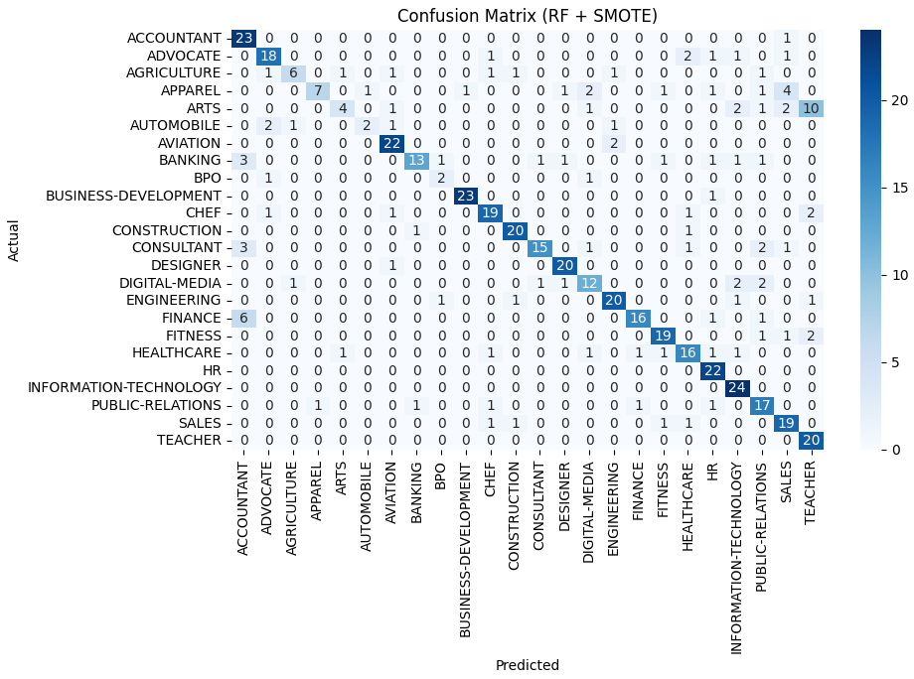

ROC Curves (RF + SMOTE)
The ROC curves are extremely strong, with most classes achieving an AUC ≥0.95 (many at 1.00). This demonstrates the Random Forest model is excellent at ranking instances correctly, even if the absolute classification threshold still needs tuning.
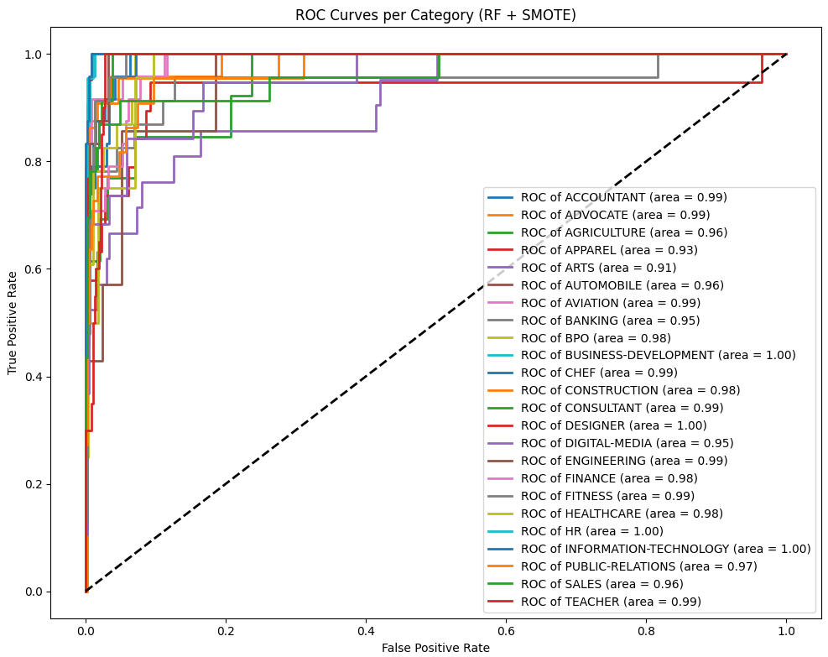
Precision-Recall Curves (RF + SMOTE)
The PR curves are highly variable. While many classes are near the top (≥0.90 AUC), the curves for 'ARTS' (0.60), 'AGRICULTURE' (0.68), and 'BPO' (0.24) are notably lower and jagged. This indicates that while the model found a signal, it still struggles to maintain high precision without sacrificing recall in these sparser, complex classes.
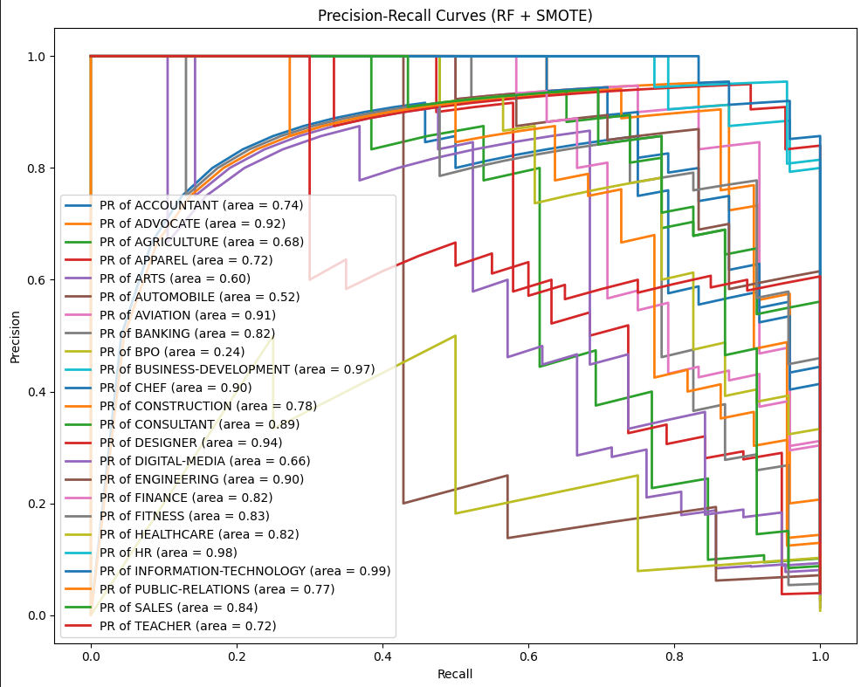

6. Conclusion and Discussion

1. Iterative Enhancement Justified
The initial failure of the Logistic Regression model ($66.80\%$ accuracy) necessitated the implementation of the RF + SMOTE enhancement¹. The linear LogReg model completely failed to classify the sparse minority classes, achieving an Automobile F1-score of $0.00$².
The enhancement successfully provided a robust benchmark accuracy of $76.26\%$ ³and proved that ensemble methods could find a signal in complex, sparse minority data⁴. The RF + SMOTE model fixed the critical failure point, raising the Automobile F1-score to $0.40$ and the BPO F1-score to $0.50$⁵.

2. Final Recommendation
The Random Forest + SMOTE model is the recommended and optimal traditional machine learning solution for deployment⁶. Its non-linear ensemble architecture, supported by synthetic data generation (SMOTE), effectively manages the complexity and imbalance inherent in multi-class resume classification⁷.
This enhanced traditional pipeline provides a significant improvement over the baseline, delivering a Macro F1-Score of $0.72$ and a substantial $+9.46\%$ increase in overall accuracy, making it a reliable and robust solution

